The Business Cycle
Fluctuations in the economy over a period of time.
1.
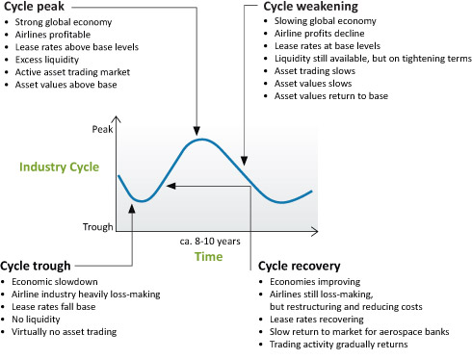
6.
3.

2.
4.

The Business Cycle
Fluctuations in the economy over a period of time.

